

Newsletter June 2016
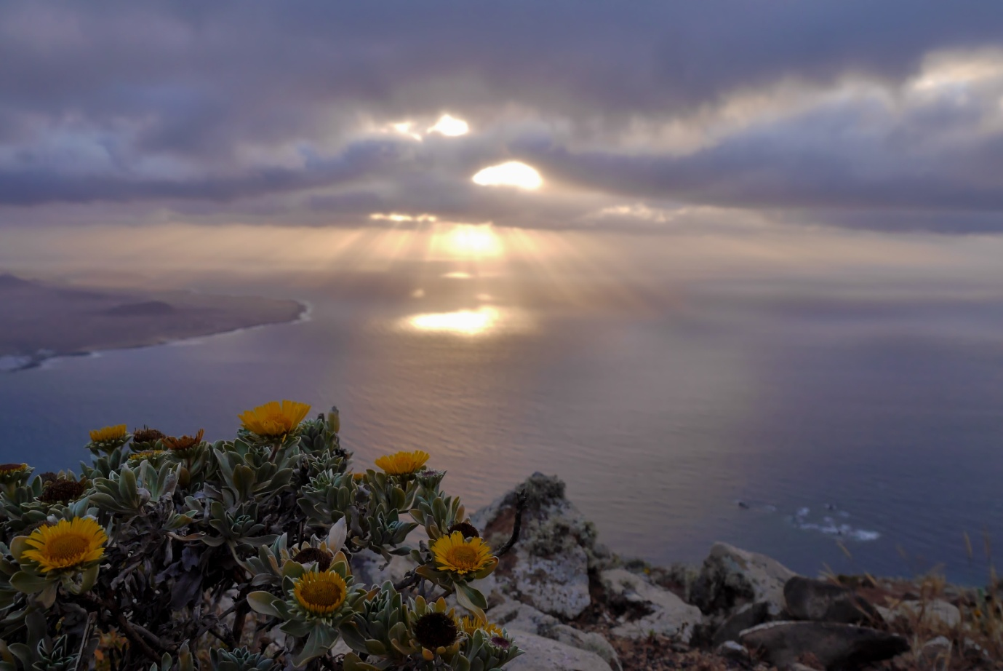
Photograph by Simon Turkas

Welcome to the June edition of your LBRA newsletter.

Well another month has whizzed past and it is incredible to think we are already almost half way through 2016; the year is just flying past. We had a busy May attending lots of meetings and of course assisting our members. We also produced a number of blogs and Vlogs with the help of Simon our social media expert and this month as a number of members have asked us for more information about Simon we have interviewed him, so you can read all about him. Have a great month everyone and as always we would welcome your comments and news.

Wedding Congratulations
We should firstly like to say Congratulations to John and Irene from Lanzarote Go Karting who got married on Friday 3rd June “We wish you a lifetime of love and happiness” Congratulations to you both.

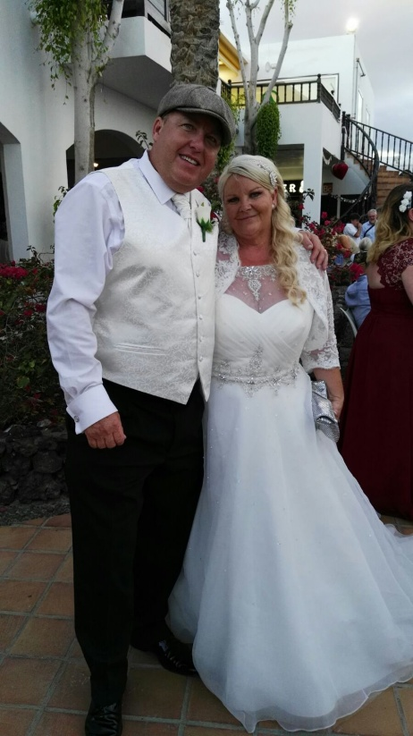

Ley de Suelo May 2016
We recently attended a breakfast meeting and presentation with the President of Canarias Fernando Clavijo presenting "Ley de Suelo." The forum was organized by Cadena Ser Radio for the President of the Canary Islands, Fernando Clavijo to explain the philosophy of the “Project of Law” to be taken to Parliament for discussion. Notes from the meeting have been sent to association members if for any reason you have not received them then please contact us.

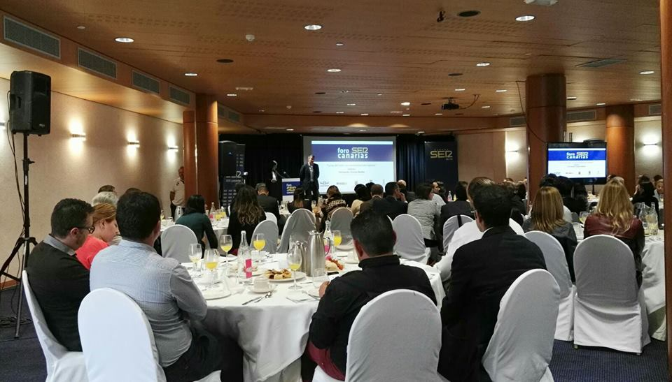

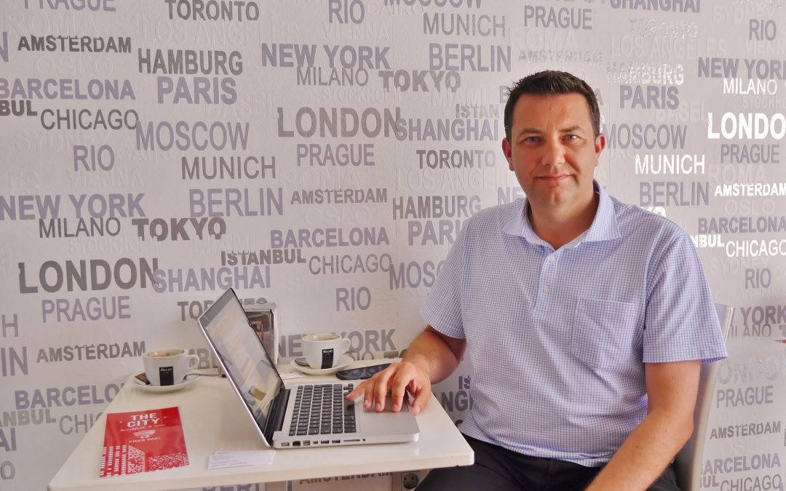

Update from Rob Head who is a Partner and Sales Consultant at Volopa, one of the growing list of LBRA members. Rob was recently on holiday here in Lanzarote with his partner Eve and their daughter Alexia, and kindly agreed to meet with us for a video interview to complement a previous written interview that appears on our website.
Volopa is a foreign exchange company with a difference, aiming for complete transparency. They offer both a Bank to Bank service and a Multi-Currency Pre-Paid Mastercard, both of which are designed to benefit indiviuduals, and allow businesses to gain greater transparency when dealing with foreign currency, ultimately saving them money. Foreign currency exchange affects the vast majority of our members, as most have connections with the UK so are faced with exchange rates and fees when switching between currencies.
In this video Rob explains the huge financial benefits that can be gained by our individual members or those who operate businesses here in Lanzarote, and also for tourists travelling to Lanzarote or other destinations worldwide.

Volopa's philosophy on their website states:
"We are Volopa - a recently launched Foreign Exchange Solutions (FX) and international payment provider delivering savings to customers on their foreign exchange transactions.
There are a number of unique benefits that Volopa customers will receive, either as Bank to Bank customers or Volopa Travel Card holders, but ultimately we can promise that our customers will always receive the most competitive exchange rates on the market.
Volopa's four core principles of Value, Security, Transparency and Simplicity differentiate us from our competitors and reinforce our commitment to give our customers...More Money Every Time."


Find out more about Volopa via their website: http://www.volopa.com/
Twitter: https://twitter.com/volopa
LinkedIn: https://www.linkedin.com/company/3136849

Plans to improve the roads and pavements in Costa Teguise
Read all about the plans at the following link
http://www.teguise.es/teguise-mejora-el-asfaltado-y-accesibilidad-de-las-calles-de-costa-teguise/

Ascav Meetings

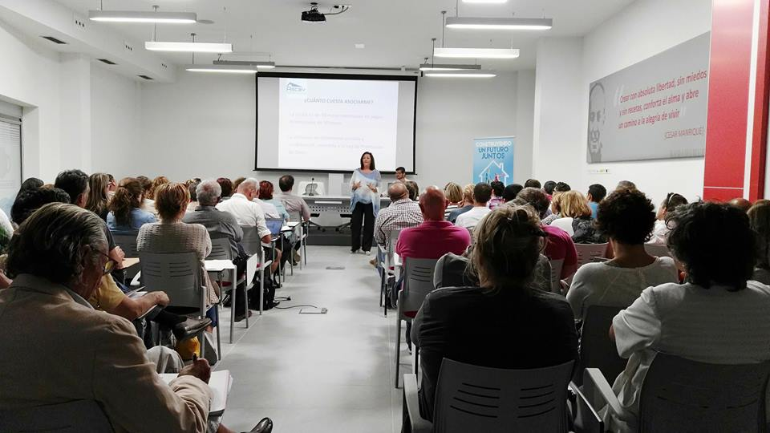

During May we attended two meetings hosted by ASCAV (Asociación Canaria del Alquiler Vacacional). A report of the meeting has been sent to members. As you will know the Minister of Tourism, Culture and Sports, Teresa Lorenzo, announced recently in the full Parliament of the Canary Islands that she expects to have a draft to amend the decree on homes for vacation rental before summer. We hope that this time it will beneficial for most holiday rental owners. A reminder as mentioned in last month’s newsletter that the authorities have announced they will be focusing their interest this year on what they say is the amount of tax unpaid due to rental property owners not declaring it. Please ensure your taxes are up to date. A number of articles have been printed in the press in respect of the meetings.
http://www.noticanarias.com/2016/05/25/conclusiones-jornadas-de-ascav-en-fuerteventura-y-lanzarote/
http://www.diariodelanzarote.com/noticia/ascav-pide-tras-visitar-lanzarote-viviendas-vacacionales-en-cualquier-suelo
http://www.lancelotdigital.com/lanzarote/ascav-acusa-a-los-cabildos-de-obstaculizar-la-incorporacion-de-las-villas-al-alquiler-vacacional

LBRA Interview
This month our interview is with Simon Turkas who started working with the association in November 2015, a number of members have asked about Simon and his blogs and vlogs so we thought we would introduce you to him.

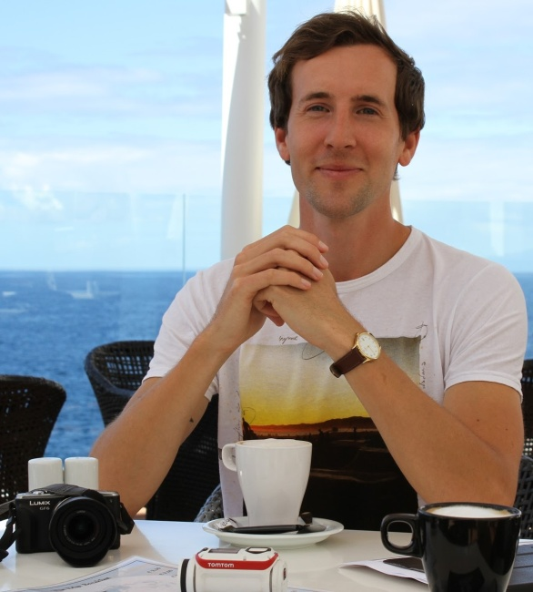

LBRA. Well we always start with this question how long have you lived here and why
Lanzarote?
Simon. Hi guys, thanks for the opportunity to introduce myself to all of the members, it has been great working for the LBRA these past six months. On this occasion I have lived in Lanzarote since last July, so for almost a year, which seems to have flown by!

I actually found out about Lanzarote from my ex partner who is from the island, and I first visited back in August 2012 for a summer vacation. Before that I knew very little about Lanzarote or the Canary Islands, but from that first trip I fell in love with the island, and have also lived here on a separate occasion for almost a year.

I decided to come back again last summer to do some voluntary work at a couple of rural yoga retreats (Kalindi in Tao http://kalindilanzarote.com/ and Casa El Morro in Uga http://casaelmorro.com/es/), both of which I found through the brilliant website Workaway (https://www.workaway.info/), that allows volunteers to connect with different hosts throughout the world. I was due to return to a job in the UK in September but found more work in Lanzarote and decided to stay.

LBRA. What exactly is the work you do for the association?
Simon. I am involved in promoting the association via its social media channels (Twitter, Instagram, Google Plus) through relevant posts, engaging with followers and trying to reach as wide an audience as possible. Each month I also write blog posts for the LBRA website and produce videos for the LBRA YouTube channel.

The topics for these posts and videos vary quite widely but in general are either based on the work that the LBRA is actively involved in for its members and the wider community in Lanzarote, or are aimed at helping to promote Lanzarote as an excellent destination for tourists.

LBRA. Has this always been your area of work?
Simon. On first leaving secondary school I did a variety of different jobs ranging from housekeeper in a hotel, to building labourer, to shop sales assistant before going to university. After finishing my degree in International Development at the University of East Anglia in Norwich in 2010 my work has included six months charity work in Bucharest, Romania; teaching English as a foreign language both in England and Lanzarote, and writing online news articles.

So in a word, no, this hasn’t always been my area of work haha. From a young age though I have enjoyed writing, taking photos and making videos, and I have been using social media for around the last 10 years since the days of Myspace. The work I have been doing for the LBRA and other clients in Lanzarote have really been fitting in with my interests, and I feel I have definitely found the niche of work that suits me after all those other types of work over the years which is a great feeling.

LBRA. You have done a lot of travel writing can you tell us more about that?
Simon. Travel is one of my biggest passions in life, and travel writing has grown from that. On the last count I have been to over 20 countries, and as well as the UK where I grew up. I have also lived in Canada, Romania and most recently Lanzarote. I really believe that travel is good for the mind, body and soul as it allows you to see incredible new places, meet amazing people and experience the rich tapestry of life that exists across this beautiful planet that we call home.

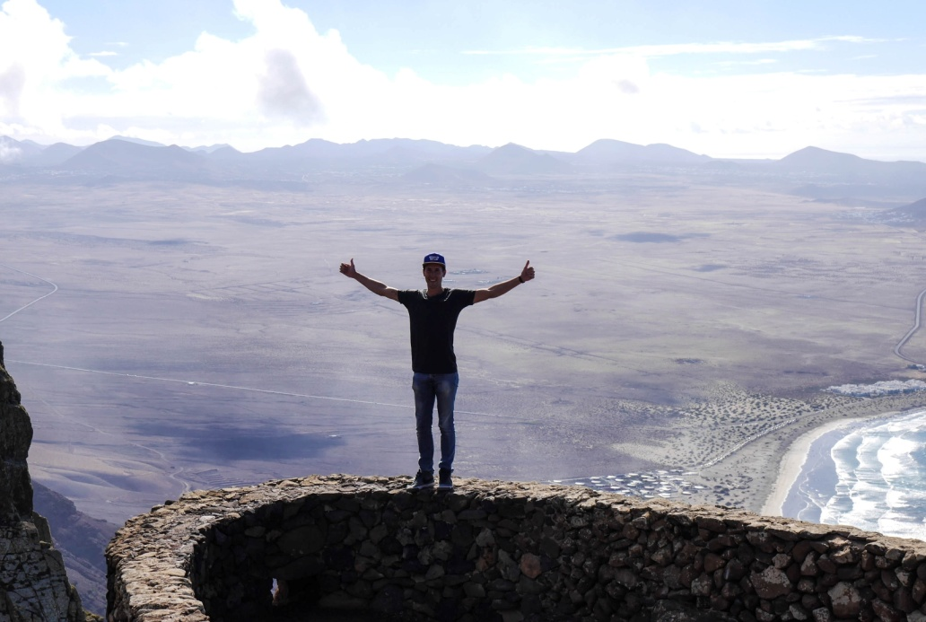

My love of travel has grown over the years since some amazing family holidays when I was a kid. These included trips to Zimbabwe, Malaysia, Australia and different destinations in Europe. My brother and I were never spoilt with the latest designer clothes, toys or technology, but I guess you can say we were spoilt with seeing the world which is something I will always appreciate. Travel literally broadens your horizons. I guess once you have been on a safari in Africa, seen dolphins in Australia, or a jungle in Malaysia, wandering around a high street in the UK doesn’t quite have the same appeal!

I decided a couple of years ago that I would combine my love of travel with my interest in writing by documenting my travels in a personal blog (http://whats-simon-saying.blogspot.com). I will soon be adding a custom domain to this which will make it easier for people to find online.

Most recently I have also become a paid travel writer as I have started writing blog posts for the official Canary Islands tourism blog (http://www.hellocanaryislands.com/blog/), and also for GoTimeshare (http://www.gotimeshare.org/category/follow-simon/) in which I recently went on a media trip to Tenerife. While there I was writing travel blog posts about my experiences, and posting about the trip across social media. A paid travel writer has been a dream job of mine for a while so I guess you could say I’m living the dream!

LBRA. We know you have travelled to many countries what has been your best experience so far?
Simon. I would have to say the most amazing travel experience I have had in my life was the all expenses included week long surfing holiday I went on to the Maldives, after winning a competition run by Tommy Hilfiger on Twitter. From one single Tweet, I won that incredible prize which included a flight to Portugal, a night’s stay there and a surfing lesson, return flights to the Maldives, a weeklong stay on a luxury yacht in the Maldives, daily surfing with a professional surfer, food and drinks, and about £200 worth of Tommy Hilfiger clothing! What’s more I was able to bring someone, but crazily enough as all my friends seemed to be busy with work or uni, my overweight, unfit, 50-something dad came along and almost drowned! Suffice it to say this wasn’t his most amazing travel experience, but he loved the Maldives nonetheless.

It was a surreal and amazing experience as there was an international mix of people who had also won the prize through Twitter or Instagram and their chosen guests, a professional travel writer, surf instructor and even a professional fashion photographer. To have won all that through a single Tweet, confirmed my love of Twitter and I’ve been tweeting a lot ever since then. Lanzarote also contributed to my win as my winning Tweet was about Famara beach!

Read more about the trip here: http://whats-simon-saying.blogspot.com.es/2013/07/tommy-hilfiger-gonesurfing-trip-to.html

LBRA. Having worked with the association would you recommend others to join it?
Simon. Absolutely as there is a great team working for the LBRA with Danny the founder and president, and Rita and Silvia who both do excellent work for the members and the wider community within Lanzarote. If you become a member of the association the team will help support you with as much as you need including translation services or assistance with dealing with local government rules and regulations. Some of the regulations for starting and running a business can be quite different in the Canary Islands compared to back in the UK, just like with any other country, and of course there is the language barrier.

When you join the LBRA though, the association is here to help with anything you may need. In addition to this the LBRA can help to promote your business via its brand new website, its monthly newsletter, and its growing social media channels which I continue to actively grow. We have close to 2,000 followers on Twitter, and over 20,000 on Facebook, so we can reach a large audience which can offer a great advert for your business!

LBRA. Anything about the association that has surprised? (you can of course mention the great people you work with haha)
Simon. This didn’t surprise me in fact haha as I knew from when I first met Danny, Silvia and Rita that it would be a great team to work with. You are all very supportive, friendly and dedicated individuals which I sensed from our first meeting all those months ago, and I have been proven correct as it has been a pleasure to work with you all. It has been a pleasant surprise to see the level of reach and connections that the LBRA has with the various local government organisations across Lanzarote which is definitely great for all the members.

LBRA. How do you like to relax?
Simon. I like to relax by getting away from the hustle and bustle of modern life, by getting out into nature either with a trek through a forest or national park, along the amazing cliffs here in Lanzarote (for example with the brilliant Lanzarote Active Club), and probably most of all by being at the beach swimming in the ocean and sunbathing. I have always loved the beach even back in the UK, but of course the beaches are a lot prettier here in Lanzarote.

It’s also great to be with friends and family enjoying a coffee and chat, a delicious meal or just a calm walk somewhere tranquil where we are surrounded by amazing scenery. One of my other passions in life is photography so it’s relaxing for me being out and about trying to get the best shot mainly of inspiring travel locations

Although I work a lot with the internet and social media, it is very important to be able to switch this off and disconnect to be able to truly relax. There is a time and place for technology, and there is a time and a place for being calm and enjoying a slower pace of life. I feel too many people are rushing through life as if it’s a race, and not stopping ever to appreciate how amazing the world is or giving themselves some precious time to relax.

LBRA: How do you relate living in Lanzarote to other places?
Simon. This relates a lot to my previous point in fact about taking things a bit more slowly and giving your mind and body some time to relax sometimes. I’ve always found life in the UK quite stressful in terms of school, university and work. Everything seems to be a competition, rushed and in many ways unhealthy. This can be seen in the growth in depression and stress related diseases across the UK and other so-called developed nations.

Unfortunately people are always encouraged to want more and more things, like a bigger TV, newer car, more expensive clothes, rather than being happy with what they have and appreciating their friends and family, and simpler but ultimately more rewarding pursuits like watching a sunset at the beach, or enjoying a coffee with some friends.
This stress and general rushing through life was also evident in Canada and Romania, but in both those places not to the same extent as back in the UK.

Life in Lanzarote is very tranquil and calm, and definitely moves at a more relaxed pace. People in general seem a lot happier and friendlier than the UK. There is more of a family atmosphere, and people are more willing to talk to strangers and engage in friendly conversations wherever you go. There does seem to be a special energy on the island because of the amazing landscape and the inhabitant’s unique connection with nature. It is also much less built up and commercialised which for me personally is great. I think this non-commercial aspect is the kind of tourism that should be encouraged as opposed to mass packaged holidays that have blighted other islands, and other parts of Spain.

LBRA. We know you are a vegan have you always been one?
Simon. Many years ago I was a vegetarian, before it was so popular, up until the age of about 16. During our family trip to Malaysia though I started eating some meat, and then unfortunately went back to being a meat eater. Very recently though I have seen the error of my ways again haha after watching a famous documentary that you may have heard of called Cowspiracy. I watched this last October, and since then just couldn’t justify eating meat or any animal products. While I don’t want to preach, I definitely recommend at least watching Cowspiracy and doing some research yourself.

I’m very happy to see though that veganism is growing rapidly across the world, and that Lanzarote is becoming an increasingly vegan friendly place. There are even completely vegan cafes and restaurants in Arrecife which is amazing! For me personally I would say it was one of the best decisions I’ve made in my life turning vegan.

LBRA. Favourite places to visit in the island?
Simon. There are so many incredible locations here in Lanzarote which is amazing considering how small the island is! I love Famara beach, both down at beach level and up from the highest point of Lanzarote, Peñas del Chache, where you can enjoy an incredible view of Famara and across the volcanic landscape of Lanzarote. Famara will always hold a special place for me as in my winning Tweet for the Maldives holiday I mentioned that Famara beach, with its stunning cliff backdrop is a great place to surf. There are various awesome beaches including Papagayo beach near Playa Blanca one of the most beautiful of the Canary Islands, and Playa Chica in Puerto del Carmen which is amazing for snorkelling or scuba diving due to its abundance of fish.

I would say possibly my overall favourite place which is kind of a hidden spot, especially from tourists, are the incredible natural swimming pools of Los Charcones. You can see them in my YouTube video > https://www.youtube.com/watch?v=C2rWXzbcSfA. I don’t want to give too much away though so watch the video and go find them yourself if you like the look haha.

LBRA. Anything people would be surprised to know about you?
Simon. Well as you already know I love social media, as it is both my job and a great way to connect with the world. As well as winning the trip to the Maldives through a single Tweet, Twitter has also lead indirectly to most of the work I’m doing now for clients in Lanzarote and outside. This is because I got into contact with John Beckley last summer on Twitter about working with him, as I noticed he has a large social media influence and following too. Through connecting with John this lead to connecting with the LBRA and now many other opportunities including paid media trips. A big thanks to John who you can find out about here: https://branded.me/johnbeckley

Back in my school days I used to be painfully shy, due to lacking confidence, partly due to having terrible acne. I never wanted to speak up in class and hated presentations or class debates. Over the years I have gradually been able to overcome this though after meeting some great people and just believing in myself more.

Now I’m getting paid to do what I love which is travel writing, I have met loads of great people both in real life and online, and I’ve even started making vlogs on my YouTube channel. I would never have believed that back in my secondary school days. I want to help inspire others to see that school is not your life, and although of course it can be tough, just keep going and you will make it. If I can be doing what I’m now doing then believe in your goals and dreams, and you can have an awesome life!

LBRA: Describe Lanzarote in 5 words?
Simon. Stunning, welcoming, intriguing, beautiful, Lanzahotty haha

LBRA. And what’s next?
Simon. There are some big things on the horizon for this summer and for the rest of the year. Following on from the successful media trip for the RDO and GoTimeshare to Tenerife in April, I will be heading to Malaga at the end of this month for another media trip to stay at a Club La Costa World resort. I will be there with John Beckley, and Siboney Tabares King (http://www.sibotk.com/) who is an amazing photographer and filmmaker. While there we have a whole host of amazing excursions planned. This trip could actually overtake the Maldives trip as best I’ve ever done!

I hope to continue to grow my social media presence (Twitter, Instagram, Vine), my YouTube channel, and expand my personal blog and travel blogging experience and work. I also want to try to inspire others to live healthier, happier lives, (through veganism maybe?! ) and pursue their own dreams.

You can follow me here:
Twitter: https://twitter.com/SimonTurkas
Instagram: http://instagram.com/simonturkas
Vine:https://vine.co/Simon.Turkas

LBRA. Simon many thanks for sharing your “life” with us it’s been fascinating to learn more about you, and it looks like you have a great future ahead of you. You can see more of Simon’s work below and of course you can contact him at the details shown above.

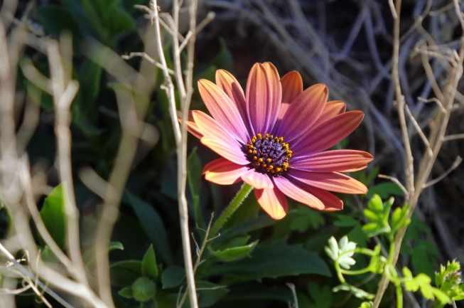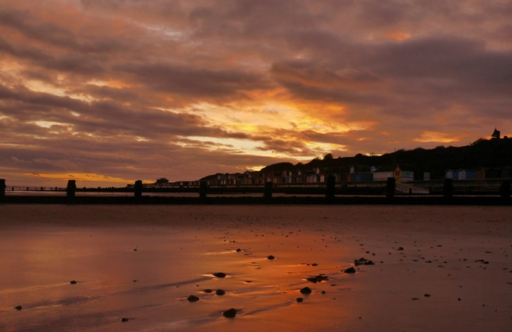

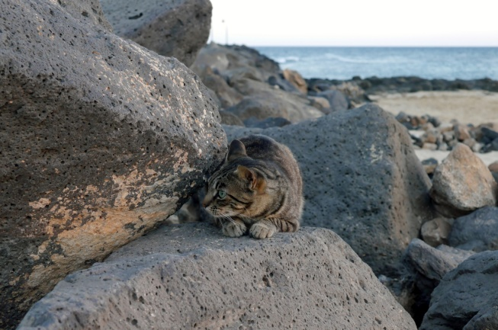

Central de salud
New link for making appointments on line with the doctor or nurse at your local central de salud.

http://www3.gobiernodecanarias.org/citasalud/

Radar Alerts

New radar devises are being installed throughout Spain that will be able to detect not only speeding but if you are wearing a seatbelt or using a mobile phone. As recently published in El Confidential.
http://www.elconfidencial.com/tecnologia/2016-04-30/los-nuevos-radares-ya-estan-entre-nosotros-y-te-van-a-pillar_1192847/

Flight news
The government is hoping to introduce a new flat rate price for residents for flights between the Canary islands. http://www.20minutos.es/noticia/2749338/0/vuelos-canarias-tarifa-plana-avion-interinsulares-gobierno-autoriza/



Committee Meeting
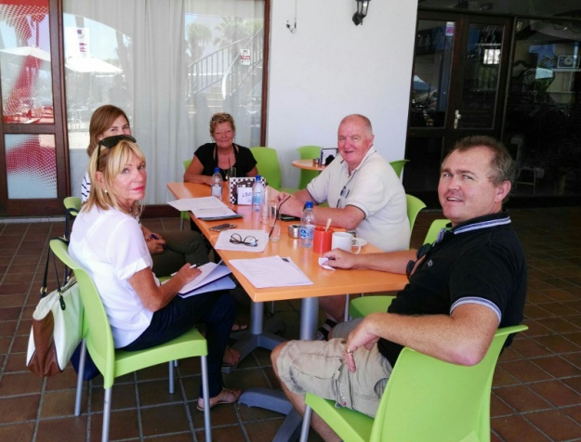

We recently held a committee meeting at the Highlander Two, one of the topics that were discussed was the need to have more social events for our members and we would welcome your ideas and suggestions. One thing we would like your help on is a new idea we have and we would ask you to forward us 10 “key search words” you would look for if planning to move to Lanzarote. Thanks to Sharron for her hospitality.

Costa Sal BBQ and entertainment
We invited members to join us at the May BBQ hosted by Geraldine and Robbie McFadden at Costa Sal; and we would like to say a huge thank you to them and their staff at Costa Sal for the fantastic BBQ and entertainment they provided. The food was fabulous and the entertainment from Lydia Lauren and band was amazing. A special mention for Lara whose performance was brilliant (A future star for sure) Great atmosphere so thank you everyone and we cannot wait till October for a repeat performance! Hopefully more members will be able to join us then.
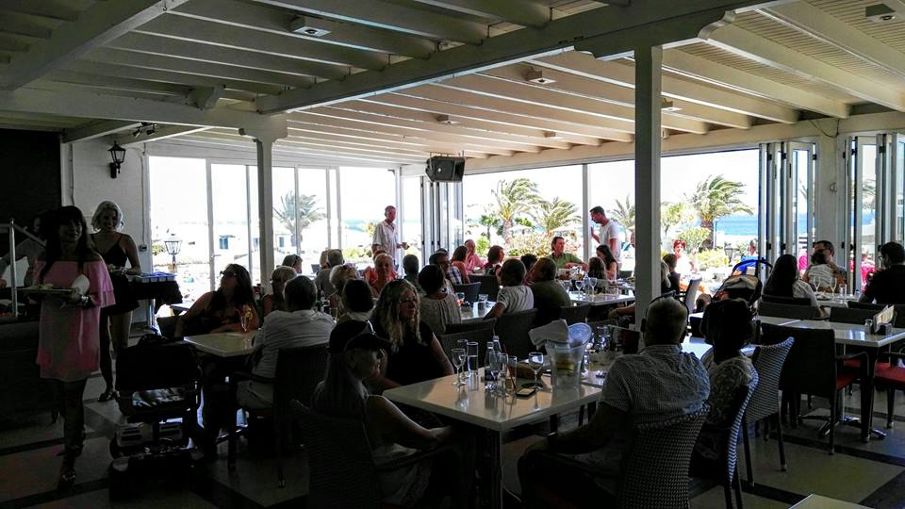
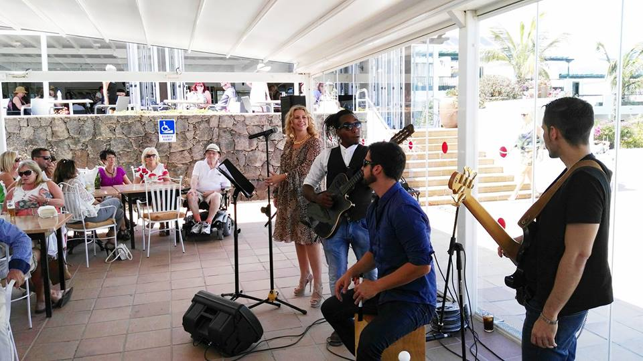

We hope you have enjoyed this edition and as always would welcome your comments and suggestions.
Best wishes
Danny, Silvia, Rita and the LBRA Team

Address: Local 63/64, Centro Atlantico,
Puerto del Carmen, Tias, 35510, Lanzarote, Las Palmas, Spain
Email: lanzaroteba@gmail.com
Website: http://lanzarotebusinessassociation.com/
Twitter
Instagram
Facebook
YouTube

